EVENT DESCRIPTION SHEET
(To be filled in and uploaded as deliverable in the Portal Grant Management System, at the due date foreseen in the system.
Please provide one sheet per event (one event = one workpackage = one lump sum).)
PROJECT
Participant: | 1 – Municipality of Plášťovce - Plášťovce
PIC number: | 920293709
Project name and acronym: | Together we shape Europe’s Story - PLA2026

EVENT DESCRIPTION
Event number: | 101291565
Event name: | Together we shape Europe’s Story
Type: | Opening ceremony, brainstorming, discussions, community café, presentations, final meeting of partners, cultural and social activities,
In situ/online: | in-situ
Location: | Slovakia, Plášťovce
Date(s): | 07.08.2026 – 09.08.2026
Website(s) (if any): | www.plastovce.sk
Participants
Female: | 150
Male: | 140
Non-binary: | 10
From country 1 [Slovakia]: | 90
From country 2 [Hungary]: | 180
From country 3 [Estonia]: | 30
Total number of participants: | 300 | From total number of countries: | 3
Description
Provide a short description of the event and its activities.
Our project strengthened cooperation among municipalities in Slovakia, Hungary and Estonia. Over the three days, the event successfully combined youth participation, intercultural exchange, civic engagement, and cultural activities. It created a platform for dialogue between citizens and municipalities, promoted European values such as solidarity and cooperation, and generated practical ideas for the development of modern, inclusive communities. For participants was prepared an interesting programme.

On 07 August 2026
The first day of the event focused on welcoming participants, creating an inclusive atmosphere and initiating intercultural dialogue through informal and interactive activities. The programme began in the afternoon with the Community Café, which served as an open and welcoming space for participants of all ages. Visitors engaged in informal discussions in small groups, sharing ideas about the future of their communities, intergenerational relationships and inspirations from other countries. This activity fostered early networking, encouraged participation and created a friendly environment for the days ahead. The activity Children and their Rights introduced younger participants to basic human and children’s rights through experiential learning. Using symbolic objects and guided discussions, children explored concepts such as the right to education and protection, supporting early awareness and prevention of bullying and violence. The Opening Ceremony formally launched the event, bringing together representatives from partner cities. The programme and key themes were presented, emphasizing cooperation, cultural exchange and citizen participation across Europe. The ceremony set the tone for the entire event and highlighted its objectives. The evening concluded with the European Dance Hall, an interactive cultural activity where participants explored traditional dances and games from different countries. Through guided workshops, attendees learned about cultural heritage in an engaging and practical way, strengthening intercultural understanding and participation.

On 08 August 2026
The second day represented the core of the programme, combining discussions, youth participation, cultural exchange and community recognition. The morning began with the discussion platform The Municipality as a Creator of the Educational Environment, where representatives of municipalities engaged in structured dialogue through thematic tables. Participants exchanged experiences on the role of municipalities in education, informal learning opportunities, and future visions for “learning municipalities.” The activity resulted in shared insights and recommendations, strengthening European cooperation and mutual understanding. Throughout the day, the Community Café continued to operate as a dynamic space for informal interaction, idea-sharing, and networking among participants of all generations and backgrounds. The Children and their Rights workshops were implemented in multiple sessions, ensuring accessibility for a wider group of children and reinforcing the importance of human rights education from an early age. In the afternoon, young participants engaged in My Village of the Future – Part 1, where they worked in groups using brainstorming and elements of Futures Literacy. They explored themes such as physical space, social life, and participation, generating creative ideas about modern, inclusive, and attractive communities for the future. Simultaneously, the cultural programme The Culture of Modern Europe presented diverse musical performances by bands from participating countries. This activity highlighted contemporary European culture and created an informal and vibrant atmosphere for interaction. A key moment of the day was the Citizens’ Appreciation – Solidarity and Culture as Pillars of Community award ceremony. Individuals and groups who contributed significantly to community life, solidarity and cultural development were recognized, reinforcing civic engagement and shared European values. This was followed by Culture without Borders – Grand Opening of the Amphitheater, a ceremonial inauguration of a newly renovated cultural space. The event symbolized cultural cooperation and included speeches from partner representatives and a symbolic planting of a friendship tree. The day continued with the moderated panel Discussion and Inspiration – Solidarity in Practice, where awarded citizens and international guests shared their experiences, challenges and motivations. This session provided concrete examples of active citizenship and inspired further engagement.

On 09 August 2026
The final day focused on consolidating results, developing concrete outputs and evaluating the overall project. The main activity, My Village of the Future – Part 2, built upon the ideas generated in the previous day. Young participants worked collaboratively to process and refine their proposals, focusing on shared challenges across municipalities. They developed practical, transferable solutions aimed at improving participation, community life and local governance. This activity emphasized European cooperation and youth involvement in decision-making processes. In the evening, representatives of partner cities participated in the Final Meeting of Partners, where the project’s implementation and outcomes were evaluated. The discussion focused on achieved objectives, lessons learned and future cooperation opportunities, ensuring sustainability and long-term impact of the project.

All-Day Activities
Throughout the entire event, the Local Art Exhibition was accessible to participants and the public. Artworks created by local artists from participating municipalities were displayed across various indoor and outdoor locations, including historical and cultural sites. This “journey for culture” encouraged visitors to explore the municipality, discover its heritage, and experience diverse forms of European artistic expression. The exhibition strengthened local identity, supported artists, and enriched the cultural dimension of the event.
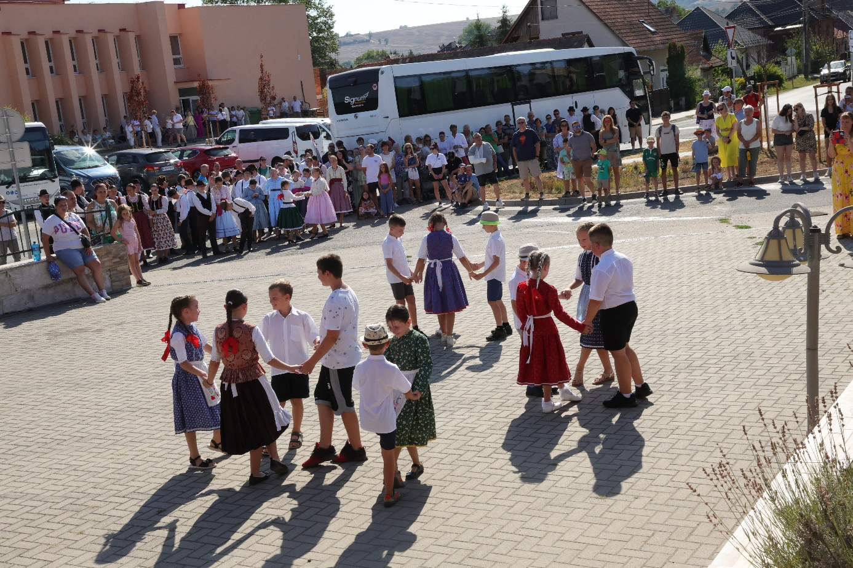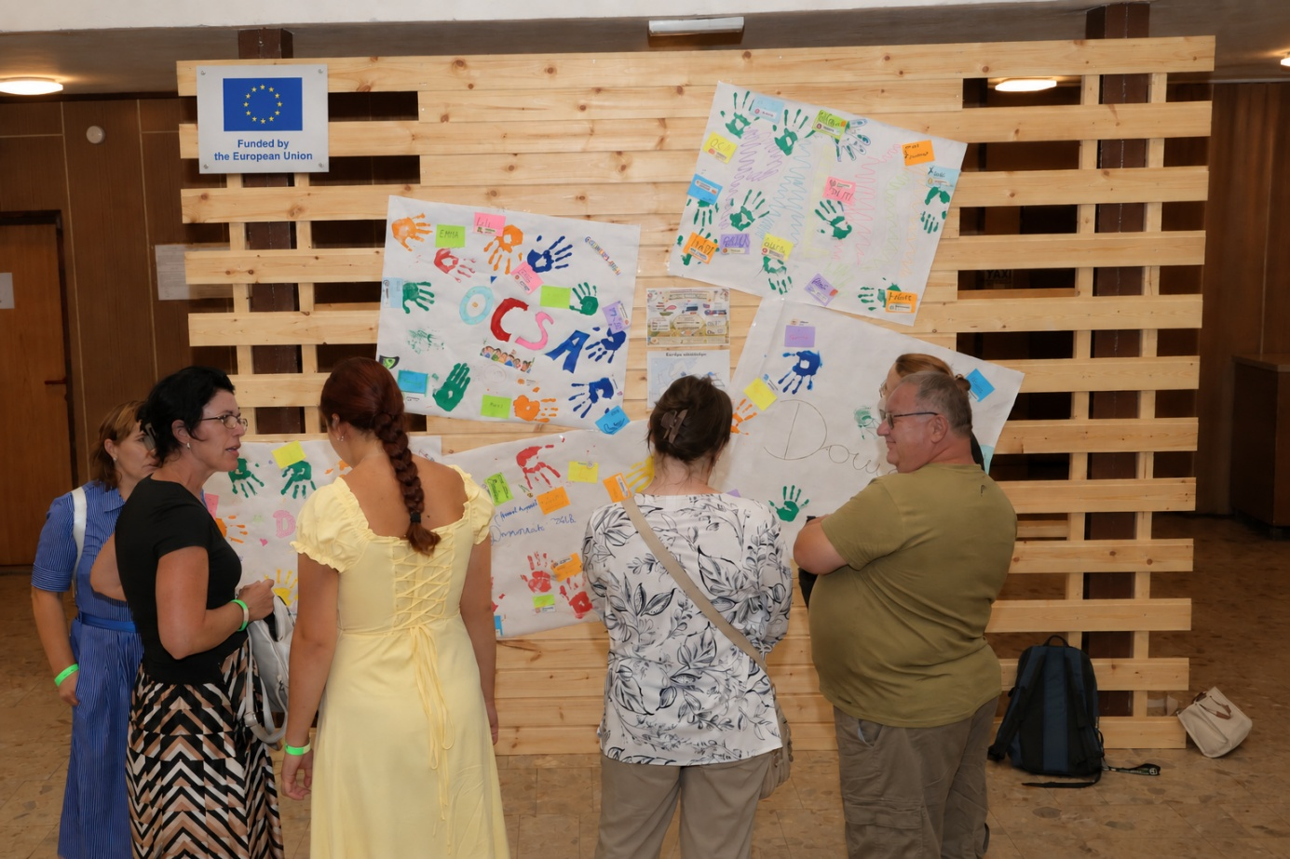

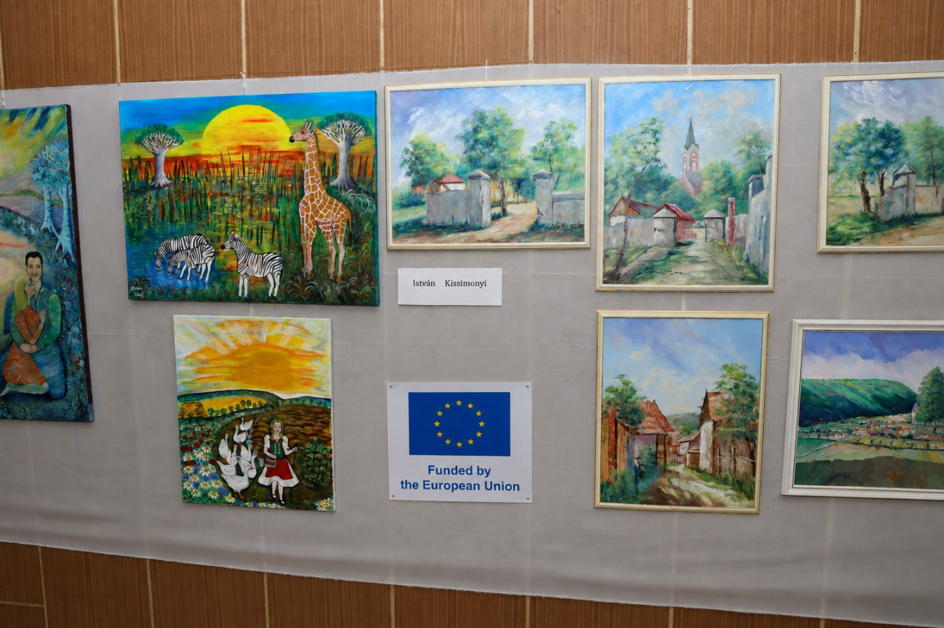

HISTORY OF CHANGES
VERSION | PUBLICATION DATE | CHANGE
1.0 | 01.04.2022 | Initial version (new MFF).

